Launching a Collaborate Session from Blackboard

Now that you have created your Collaborate session now it’s time to use it. As a professor, you will can launch your Collaborate session from a course home page. Click here for a sort video introduction of Collaborate Ultra.

To launch your Collaborate session you need to follow these steps.
- From your course home page, choose the Course Tools and Blackboard Collaborate Ultra.
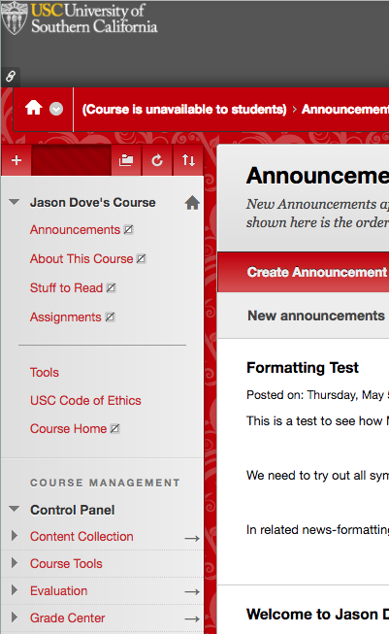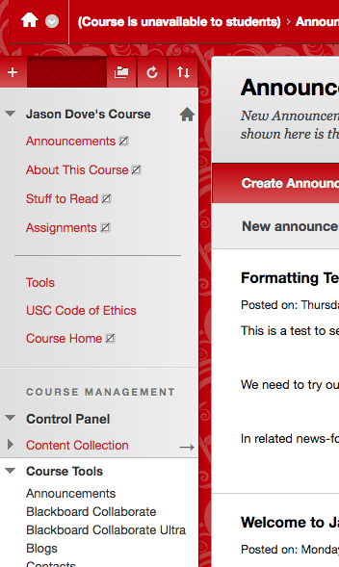

- The Collaborate module will open and you will can launch your session by clicking on your session name. In this case, we will be launching the Test Session.
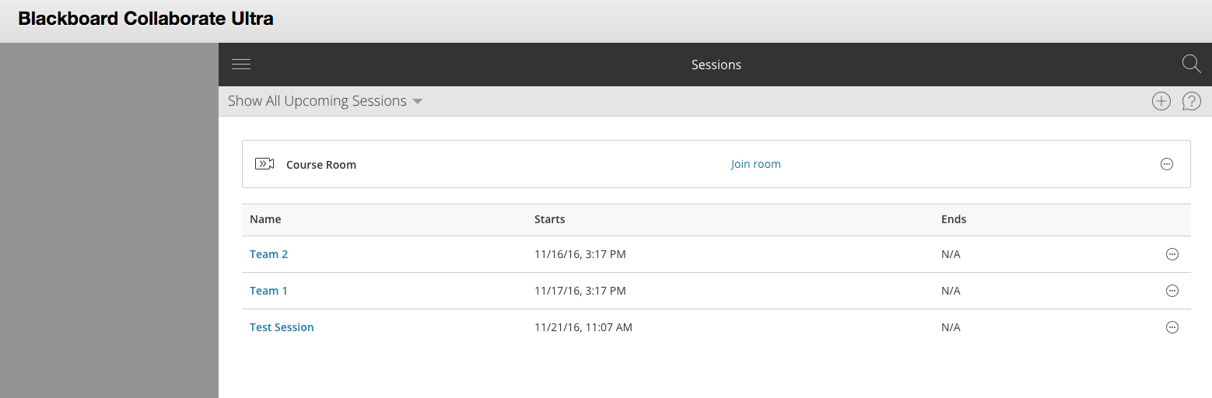
- Your session will open and you are ready to start collaborating.
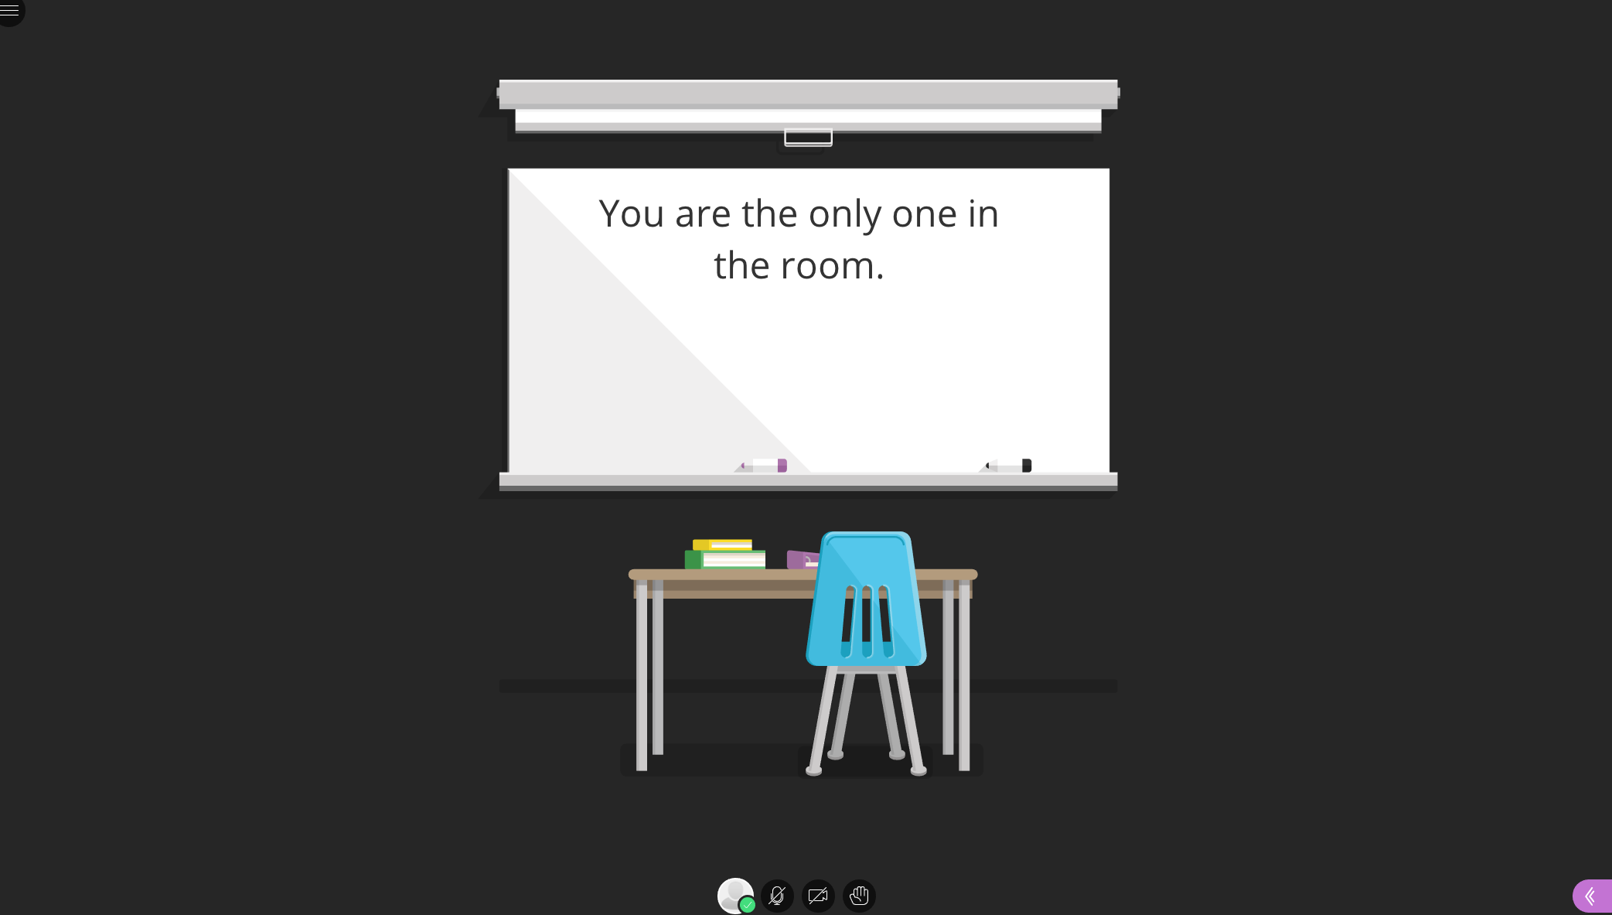

Once you have launched your session there are many things you will be able to do. For more information on how to utilize the Collaborate Ultra module you can follow the links below for more detailed instructions.

- What browser should I use?
- How do I record a session?
- How can you call into a session for the audio? (Note, only 25 people can use this feature per session.)
- How do I share content as a presenter/moderator?
- How do you use/set up the audio and video portion of Collaborate?
- How do I set up closed captioning for the hard of hearing?

