Creating a Collaborate Session from Blackboard

If you need to hold an online meeting, USC offers, free of charge, the Blackboard Collaborate Ultra video conferencing system. To launch Collaborate and to create a Collaborate session you must follow these steps.

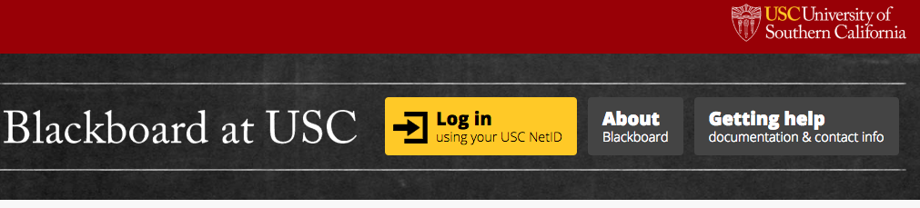
- Launch Blackboard. To launch Blackboard, you need to go to blackboard.usc.edu and click on the yellow box that says Log in using your USC NetID.

- After you click the yellow box that says Log in using your USC NetID a screen will appear that will allow you to enter your USC NetID and password. Click Enter (You will need your mobile device to “approve” the log in. After approval of log in, Blackboard will launch.).
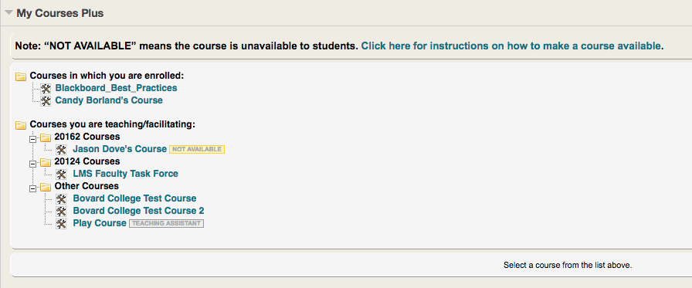
- Select the course and section you wish to log into. You can even log into courses which are NOT AVAILABLE to your students. After clicking the course name, you will be taken to your course’s Blackboard page. (Note, you will see the courses assigned to you and NOT the courses listed in the picture.)
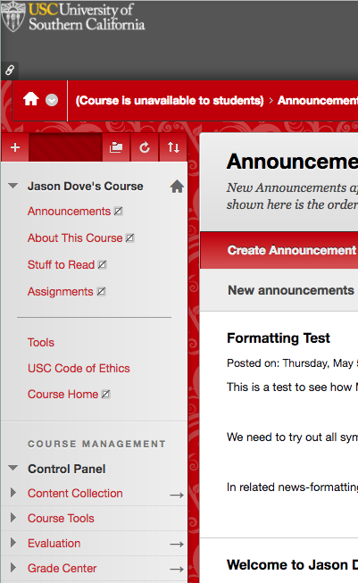
- In your Blackboard course, you will need to click on the Course Tools drop down. The Course Tools drop down may be in a different order but should always be on the course home page. (Note, your course home page may look different than the page pictured.)

- The Course Tools dropdown will allow you to click on the Blackboard Collaborate Ultra link to launch Collaborate. Make sure you select Blackboard Collaborate Ultra if you have 2 different versions of Blackboard Collaborate in your menu.

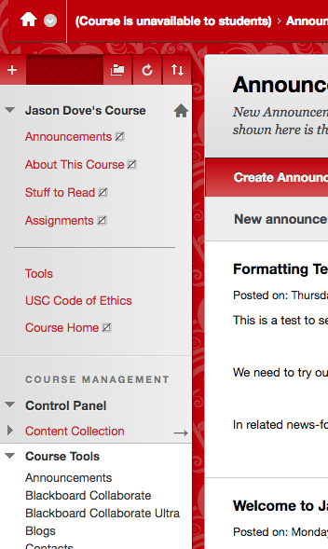
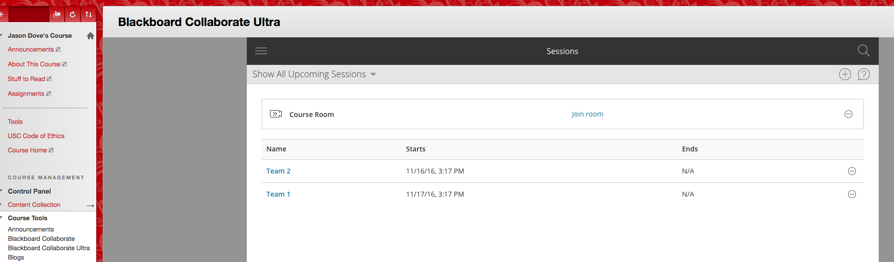
- The Blackboard Collaborate module will launch and you will be able to schedule a session by clicking on the + sign in the upper right hand corner of the module.

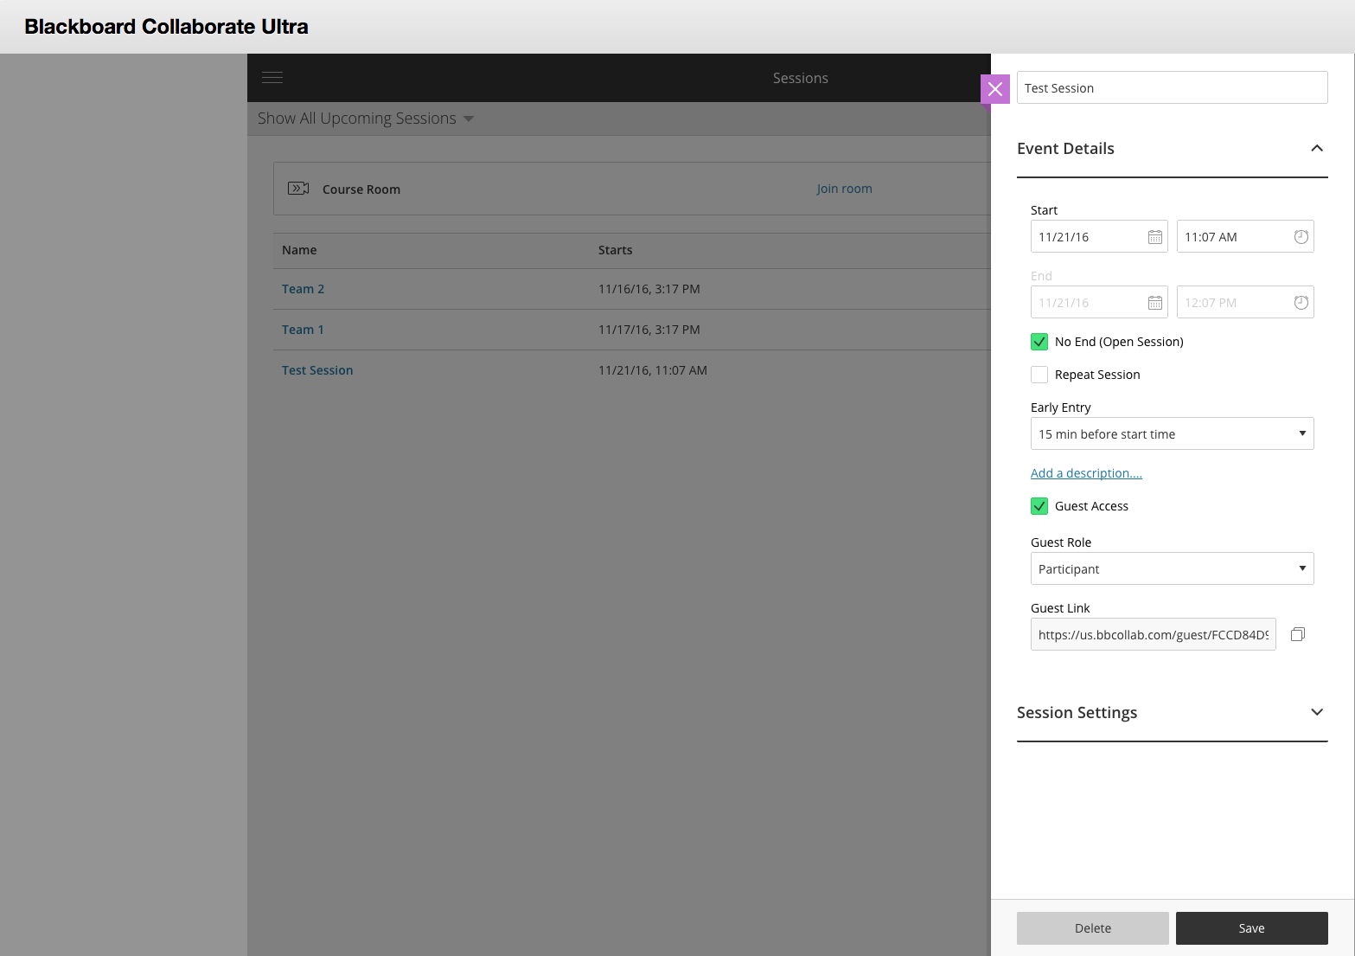
- The Session Scheduler will open. For the Event Details, a Session Name is required but a start and stop time is not. If you want an open-ended session click the “No End” option. If you want to add a description of what the session is about (not required), click on the Add a description… link. If you’d like to allow guest access (access for people outside of your course) check the box and assign them a role for when they join your session. You should copy the Guest Link to share with guests (click the 2 squares icon to the right of the address).

- After entering Event Details, click on Session Settings to fine tune who can do what in the session. As the creator of the session you will automatically be set up as a Moderator. You will have the choice to have your guests enter the Collaborate session in one of 3 roles (guests default to the Participant role).
  - Default Participant Role allows you to set how your participants will be classified.
    - A Participant can watch, type in the chat window, participate in polls, raise their “hand”, draw on a white board, but cannot share content or control the session (participant actions are listed under d below).
    - A Presenter can do everything a Participant can do with the addition of sharing content from their computer, but cannot determine a participant’s role.
    - A Moderator has all the features of participant and presenter but can also control the session (start/stop recording, assign roles, etc.).
  - Recording
    - This allows your students to download the recordings.
  - Moderator Permissions
    - This allows only the moderators to see profile pictures.
  - Participant can features allow the participants to share audio, video, post chat messages and draw on the white board and files.
  - Enable Session Telephony
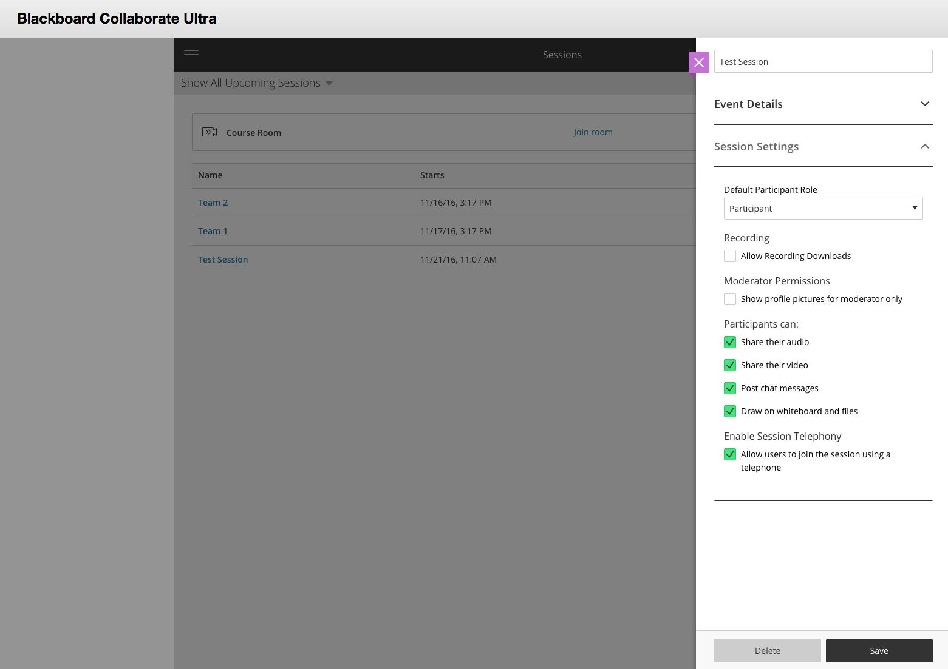
    - This allows participants to dial into your session and not have to use a computer. (Note, only 25 participants can use this feature per session, so it’s best to use your computer’s mic and camera.)

- Click Save in the bottom right corner of the screen and this will save your session. You are now free to send your guest link out to your participants.

